
FAKULTI TEKNOLOGI KEJURUTERAAN ELEKTRIK DAN ELEKTRONIK

BTS4723
SOFTWARE ENGINEERING PROJECT PROPOSAL

COMPANY NAME: CYBERATHLETES
SOFTWARE NAME: SPORTSPHERE

NAME | ROLE
JULIUS LIM CHUANG KIANG | PROJECT MANAGER
ROSHAN A/L SUPURMANIAM | SOFTWARE ENGINEER
YAP JING QIAN | UI DESIGNER

TABLE OF CONTENTS
DATA MODEL 3
GANTT CHART & COST ESTIMATION 6
API REQUEST/RESPONSE 8
TEST CASES 10
ETHICAL CONCERNS 11
ARTICLE RESEARCH 12
REFERENCES 13

DATA MODEL

Table 1: Player
Key | Name | Type | Sample
1 | playerID | PK | 1
2 | full_name | varchar(64) | John Doe
3 | age | int | 19
4 | phone | varchar | 0123984752

Table 2: Performance
Key | Name | Type | Sample
1 | performanceID | PK | 1
2 | goals | int | 25
3 | assists | int | 11
4 | minutesPlayed | int | 90
5 | playerID (FK) | FK | 1
6 | matchID (FK) | FK | 1

Table 3: Tournaments
Key | Name | Type | Sample
1 | tournamentID | PK | 1
2 | participants | int | 25
3 | venue | varchar(64) | Johan Sepak
4 | startDate | datetime | 2025-11-25

Table 4: Match
Key | Name | Type | Sample
1 | matchID | PK | 1
2 | tournamentID | FK | 1
3 | opponentName | varchar | Kuantan Kickers
4 | matchDate | datetime | 2025-11-25
5 | goalsFor | int | 2
6 | goalsAgainst | int | 1

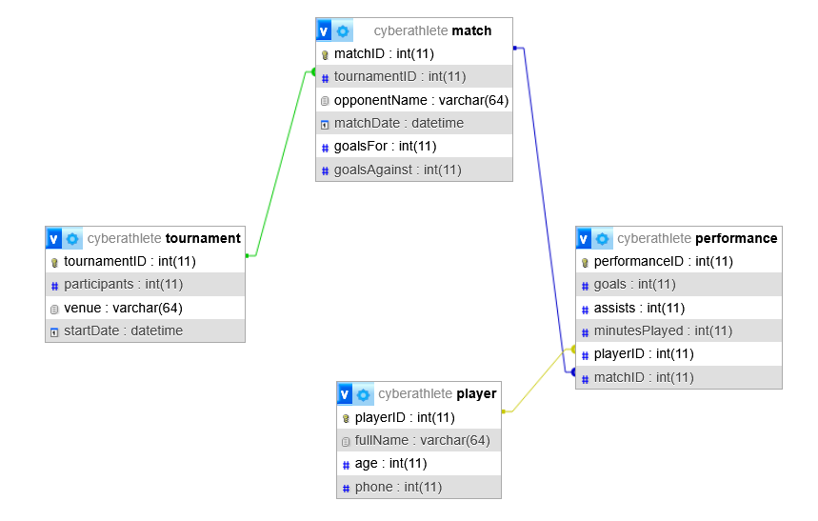
Figure 1: phpMyAdmin Designer view of our Data Model

More samples:
Table 5: Sample for Player Table
playerID (PK) | fullName | age | phone
1001 | Ahmad Albab | 19 | 012-3456789
1002 | Sarah Lee | 18 | 011-9876543
1003 | Muthu Kumar | 20 | 016-5551234
1004 | Chong Wei Feng | 19 | 019-8887777
1005 | Nurul Izzah | 17 | 013-3334444

Table 6: Sample for Tournament Table
tournamentID (PK) | participants | venue | startDate
501 | 16 | Kuantan Stadium | 2025-11-01
502 | 24 | Shah Alam Sports Complex | 2025-12-15
503 | 8 | Cyberjaya Community Park | 2026-01-10
Table 7: Sample for Match Table
matchID (PK) | tournamentID (FK) | opponentName | matchDate | goalsFor | goalsAgainst
9001 | 501 | Kuantan Kickers | 2025-11-02 16:30:00 | 2 | 1
9002 | 501 | Pekan United | 2025-11-05 16:30:00 | 1 | 1
9003 | 502 | Red Giants Academy | 2025-12-16 09:00:00 | 0 | 3

Table 8: Sample for Performance Table
performanceID (PK) | goals | assists | minutesPlayed | playerID (FK) | matchID (FK)
7001 | 1 | 0 | 90 | 1001 | 9001
7002 | 0 | 1 | 90 | 1002 | 9001
7003 | 1 | 0 | 45 | 1003 | 9001
7004 | 0 | 0 | 90 | 1001 | 9002
7005 | 0 | 0 | 20 | 1005 | 9003

GANTT CHART & COST ESTIMATION

ACTIVIITY | W1 | W2 | W3 | W4 | W5 | W6 | W7 | W8 | W9 | W10 | W11 | W12
Requirement Analysis
System Architecture Design
Database Design
UI Design
API Design
Testing
Documentation & Submission
Figure 2 : Gantt Chart

MILESTONES
Requirements finalized (End of Week 2)
System & database design approved (End of Week 4)
UI & API design completed (End of Week 7)
Testing completed (End of Week 9)
Final report & presentation ready (Week 12)

COST ESTIMATION
Table 9: Cost Estimation Table
Cost Category | Description | Estimated cost (RM)
Human Resource | 3 students × 12 weeks × RM50/week | 1800
Software Tools | Figma, GitHub, DB tools (student/free licenses) | 0
Hardware | Laptop usage & internet | 300
Documentation | Printing & binding | 50
Miscellaneous | Contingency cost | 100
Total Estimated Cost |  | 2250

API REQUEST/RESPONSE

Table 4: Sample of the API request/response
// METHOD: POST
// ENDPOINT: https://api.cyberathlete.com/v1/matches/results

// BODY (JSON):
{
"tournamentID": 501,
"matchDate": "2025-11-15",
"opponentName": "Kuantan Kickers",
"goalsFor": 2,
"goalsAgainst": 1,
"matchStats": [
{
"playerID": 1001,
"minutesPlayed": 90,
"goals": 1,
"assists": 0
},
{
"playerID": 1004,
"minutesPlayed": 45,
"goals": 1,
"assists": 1
}
]
}

// RESPONSE CODE: 200
// RESPONSE BODY (JSON):
{
"status": "success",
"message": "Match result recorded successfully.",
"data": {
"resultID": 9001,
"timestamp": "2025-11-15T18:30:00Z",
"updatedStanding": "2nd Place"
}
}

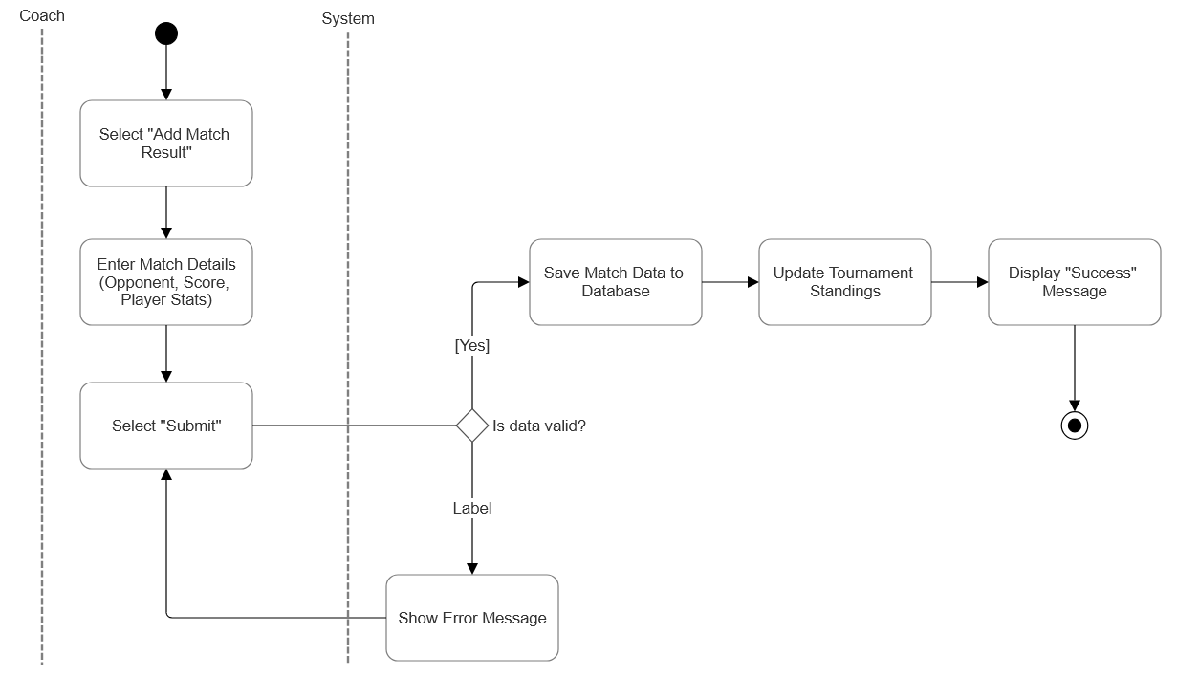
Figure 3: Activity Diagram of FR 11 with UML Design

TEST CASES

Table 10: Test Cases
Case ID | Test Description | Test Input | Expected Result
TC-01 | Verify Admin Login  Check if the system grants access to an admin with valid credentials. | Email: admin@academy.com  Password: Admin123! | System authenticates the user and redirects to the Admin Dashboard.
TC-02 | Verify New Player Registration  Ensure the system creates a new player record when all fields are valid. | Name: "John Doe"  DOB: 12/05/2006  Position: Forward  Action: Click "Save" | System displays "Registration Successful" message and the new player appears in the Player List.
TC-03 | Validate Performance Data Entry (Boundary Test)  Ensure the system rejects negative numbers for goals scored. | Player: John Doe  Goals: -1  Action: Click "Submit" | System displays an error message: "Goals cannot be negative" and does not save the data.
TC-04 | Verify Training Schedule Booking  Check if a coach can schedule a session without conflict. | Date: 2026-01-01  Time: 08:00 AM  Venue: Johan Sepak | System confirms the booking and sends a notification to assigned players.
TC-05 | Verify Tournament Search  Test the search function to find a specific tournament. | Search Query: "Pahang"  Filter: Current Year | System returns a list containing "Pahang U-21 Cup" and other matching records.

ETHICAL CONCERNS

1. Data Privacy and Protection of Minors
The system stores sensitive personal information such as full names, dates of birth, emergency contacts, and medical conditions. Since many "Sport Training Academies" work with youth (under 18), our software requires higher protection standards for saved data. A data breach could expose minors to identity theft, stalking, or harassment.
We will implement strict Role-Based Access Control (RBAC) so that only authorized staff roles (e.g., Head Coach, Physio) can view sensitive details. We will also ensure compliance with local data protection laws (such as the PDPA in Malaysia) by obtaining explicit parental consent for data storage.

2. Algorithmic Bias in Performance Evaluation
The system generates "progress charts" and potentially ranks players based on entered statistics. If the data entry is subjective (e.g., a coach consistently rating favorite players higher in "Attitude" or "Tactical Skill"), the system's output will be biased. This could unfairly disadvantage certain players regarding scholarship opportunities or team selection, leading to discrimination.
We will design the system to differentiate clearly between objective data (goals, minutes played) and subjective data (coach ratings). Subjective ratings will require mandatory text justification to encourage accountability and reduce unconscious bias.

3. Insecure Storage of Medical/Health Data
The system tracks player status, including injuries and medical conditions (e.g., "Asthma," "ACL Tear"). If this health data is stored in plain text or transmitted over unencrypted networks, it violates medical confidentiality. Leaking this information could damage a player's future career prospects or cause social embarrassment.
All medical fields in the database will be encrypted at rest. We will also use HTTPS/TLS 1.3 for all data transmission to ensure that health records cannot be intercepted during the API submission process.

ARTICLE RESEARCH

Article chosen: Big Data Analytics Framework for Decision-Making in Sports Performance Optimization
Excerpt:
This study demonstrated that an integrated big data framework, when applied through case-specific modeling and visualization pipelines, can yield measurable improvements in injury prevention, tactical decision-making, and sprint mechanics. The consistency of these effects across three distinct sports scenarios highlights the framework’s flexibility and real-world applicability. (Mănescu, 2025, p. 116)

The article demonstrates that integrating Big Data Analytics and Machine Learning (ML) into sports management systems can significantly reduce injury rates by up to 12% and improve decision-making. For the system, I propose incorporating this technology in two specific phases:
- Phase 1: Injury Risk Dashboard (Predictive Analytics)
  - How: We can upgrade the "Performance Records" module to not just store past data but analyze it. By implementing a simple ML algorithm (like Logistic Regression mentioned in the article), the system can flag players who have a "High Injury Risk" based on sudden spikes in their training workload (minutes played) or a drop in physical test scores.
  - Benefit: This moves the system from a passive "record-keeper" to an active "assistant coach" that protects young athletes.
- Phase 2: Automated Tactical Suggestions
  - How: Using the article's concept of "optimizing in-game tactical decisions", we can add a feature where the system analyzes opponent data (stored in our Match_Results table) to suggest the best starting lineup. For example, if an opponent has a weak defense, the system suggests fielding players with high "Sprint Speed" stats.

REFERENCES

- Mănescu, D. C. (2025). Big Data Analytics Framework for Decision-Making in Sports Performance Optimization. Data, 10(7), 116. https://doi.org/10.3390/data10070116

